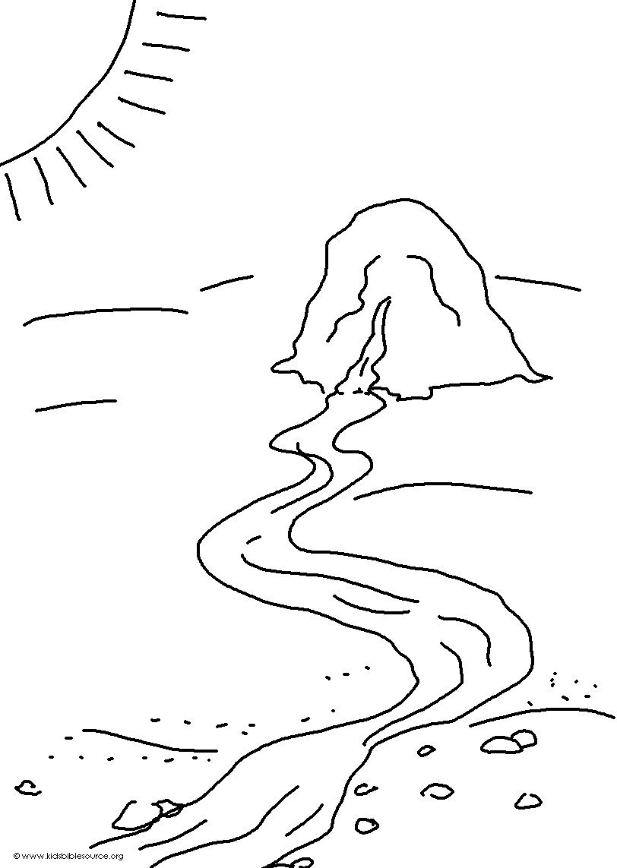
Food will be supplied to them, and they will have water
Isaiah 33:16_{NLT}

